**CS-4037 Introduction to Cloud Computing**

* **Private Cloud:**
  + a dedicated datacentre which can exist user’s on site location or off site location managed by user.
  + Private cloud can also be provided by third party.
* **Hybird Cloud:**
  + Combo of on premises fully controlled private and public cloud.
* **Multi Cloud:**
  + Using services of multiple cloud providers.

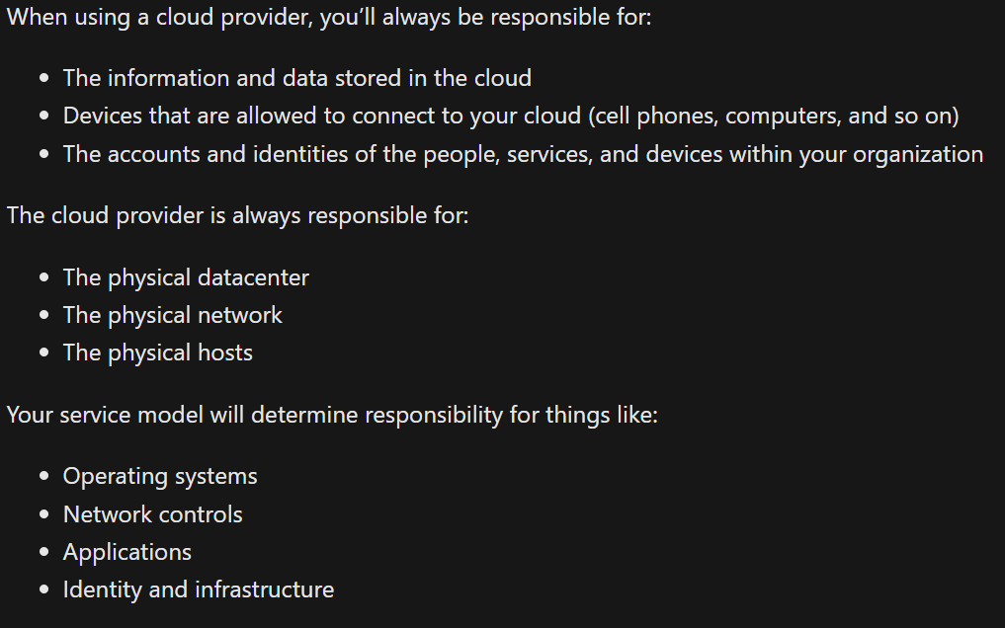

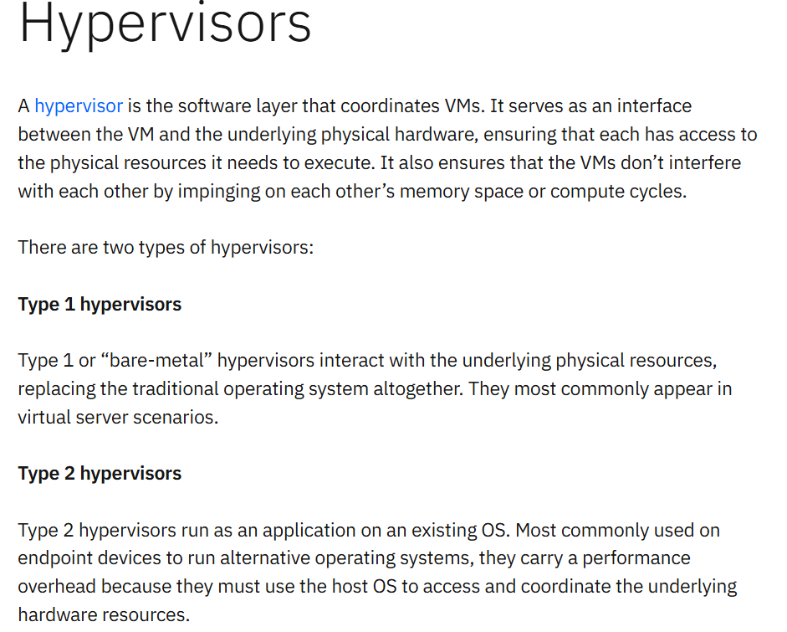

**4. Networking**

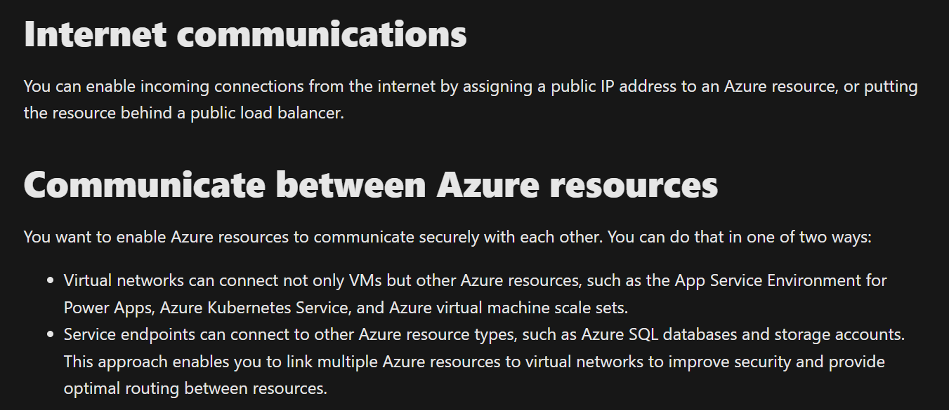 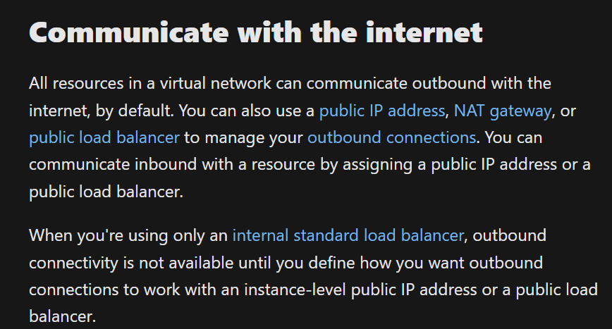

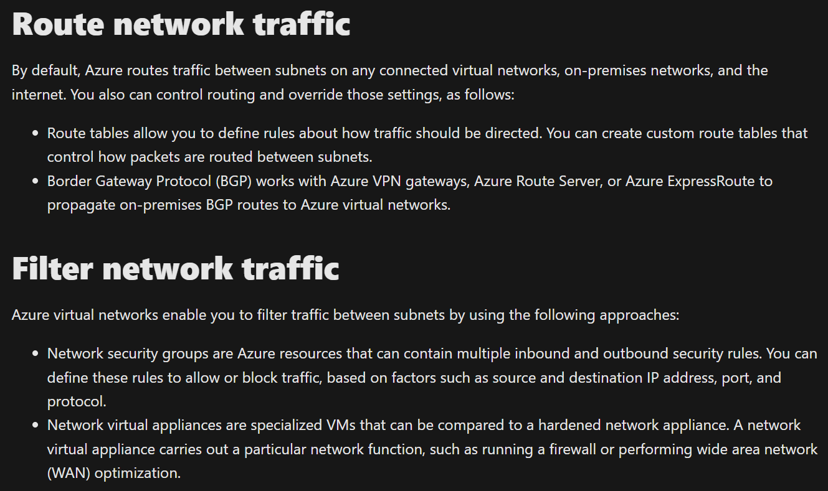

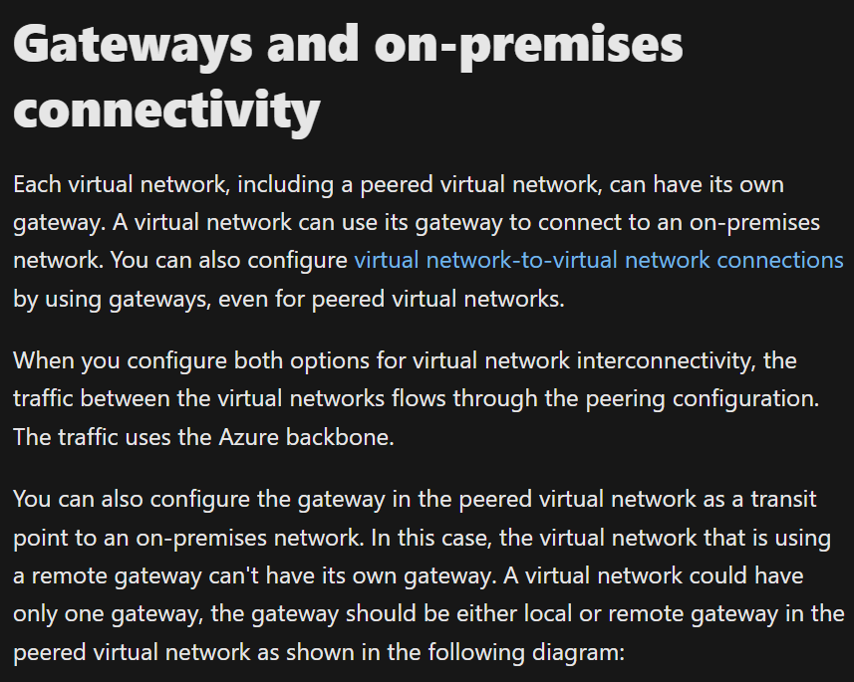

**Online revision session (23rd sept 2024)**

* Vm is the probably the only use case of IAAS.
* Fault and update domains are part of vm availability set.
* Availability zone is a datacentre in a region.
* Pod can contain one or more containers.
* Container groups are collection of containers scheduled on same vm.
* Key points to setting up a vpn
  + vpn appliances on both networks with public ip.
  + Share ipsec/ike parameters (encryption or hashing parameters).
  + Exchange pre-shared key (psk).
  + Exchange local ip address space.
* No scalability in aci.
* infrastructure as a service provides you with physical resources but lets you manage the operating systems and installed software, including patches and maintenance. If you want patches and maintenance taken care of automatically, platform as a service or software as a service deployments may be the best cloud strategies for you.
* Edge network
  + No services
  + No datacentre
  + Mainly for network and routing.

Mid 2 review:

1. Storage:
   1. Data lake:
      1. Folder structure
   2. Managed disk:
      1. no need to create storage account.
      2. Cant have unique url like storage account storages.
2. Paas compute:
   1. Cluster autoscaler checks every 10 seconds
   2. HPA checks every 10 seconds
3. Identity
   1. Entra id – SAAS
   2. Distribution group – only emails
   3. Entra domain services – adds as paas service
   4. Azure b2c example: login with google/ms/facebook in an app.

Container

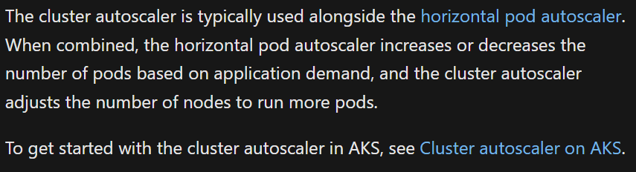

pod (can have multiple containers )

nodes (a vm on which multiple pods are)

Online lecture after mid 2:

1. Cosmos db -> for tables, queues
2. Design rule
   1. Scale the solution, do not change the solution.
3. Data factory: move data from anywhere to anywhere.

Azure Data Services

1. Data lake is for storing raw data of any type.
2. Data warehouse stores relational data.
3. Data factory provides pipelines.
4. Synapse analytics to implement data pipelines, SQL analytics, and Spark analytics.
5. Cosmos DB:
   1. The internal, document-based storage structure is abstracted, enabling developers to use Cosmos DB to store and query data using APIs with which they are already familiar.